TBMI26 – Computer Assignment Reports  
Boosting

Deadline – March 15 2019

Author/-s:

Isak Johansson-Åkhe

Omid Tern

In order to pass the assignment you will need to answer the following questions and upload the document to LISAM. **You will also need to upload all code in .m-file format**. We will correct the reports continuously so feel free to send them as soon as possible. If you meet the deadline you will have the lab part of the course reported in LADOK together with the exam. If not, you’ll get the lab part reported during the re-exam period.

1. **Plot how the classification accuracy on training data and test data depend on the number of weak classifiers (in the same plot). Be sure to include the number of training data (non-faces + faces), test-data (non-faces + faces), and the number of Haar-Features.**

All figures generated with 2000 training points and 10788 test-points.

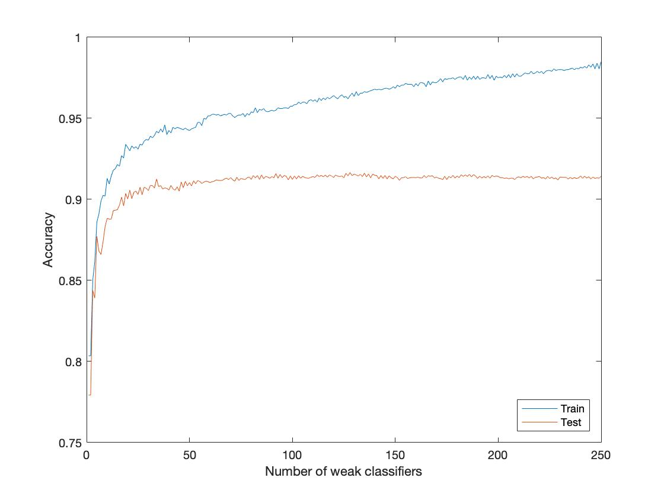

Figure , 25 HaarFeatures

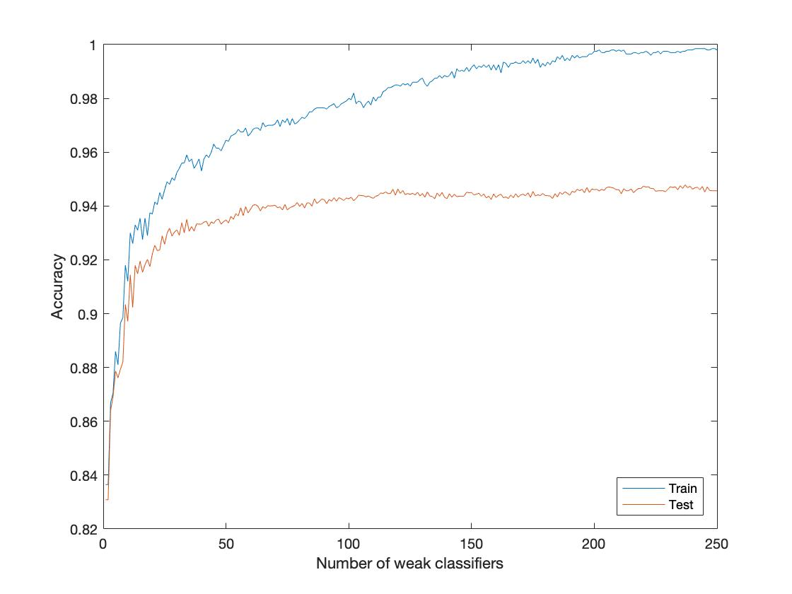

Figure , 50 Haar Features

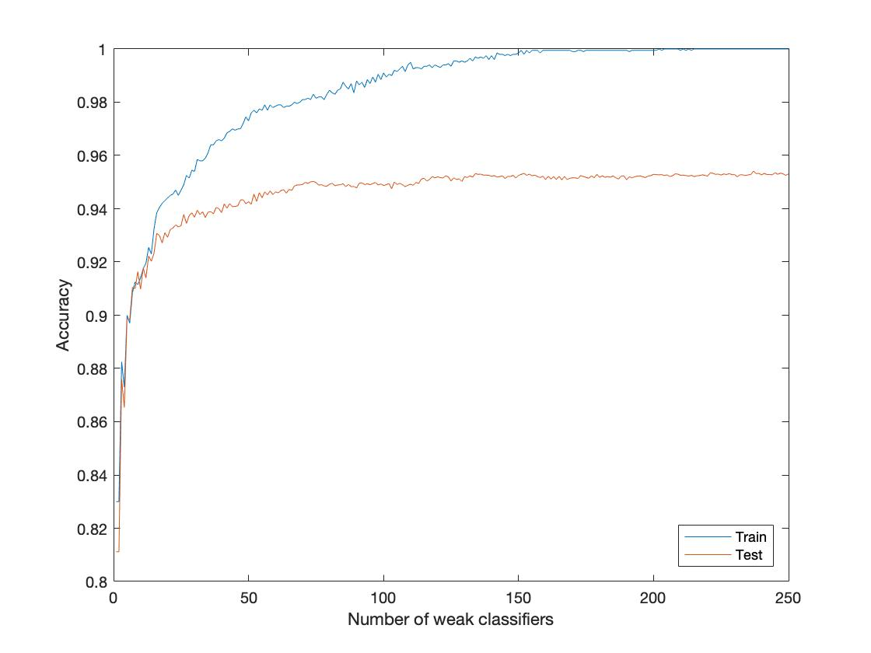

Figure , 75 Haar Features

1. **How many weak classifiers did you use when training? How many of them did you use for the final strong classifier? Why?**

We used 250 weak classifiers when training, to be sure that performance had reached maximum potential. We chose 70 classifiers as our final number of classifiers, as beyond that there was minimal increase in accuracy on test data.

1. **What is the accuracy on the test data after applying the optimized strong classifier?**

0.9491

1. **Plot the Haar-features selected by your classifier (one for each weak classifier). If you have many weak classifiers, select some representative subset.**

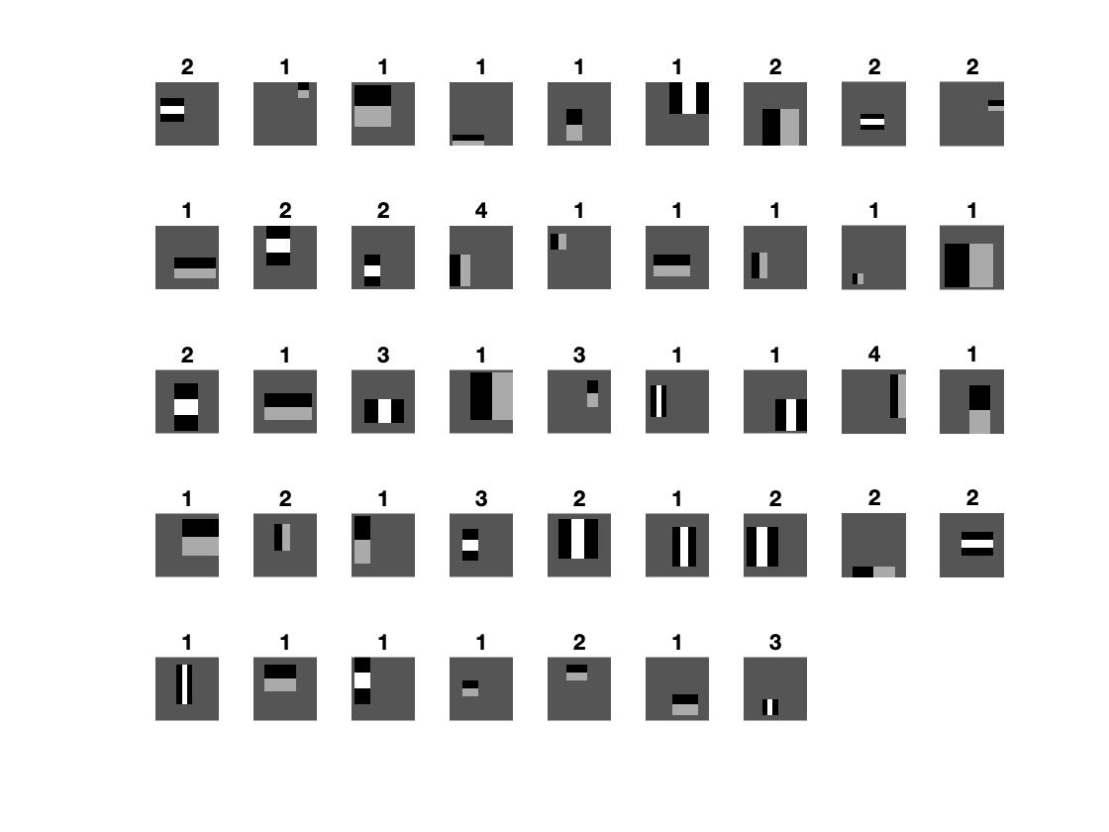

Each Haar feature is accompanied by the number of weak classifiers which use it.

1. **Plot some of the misclassified faces and non-faces that seem hard to classify correctly. Why do you think they are difficult to classify?  
   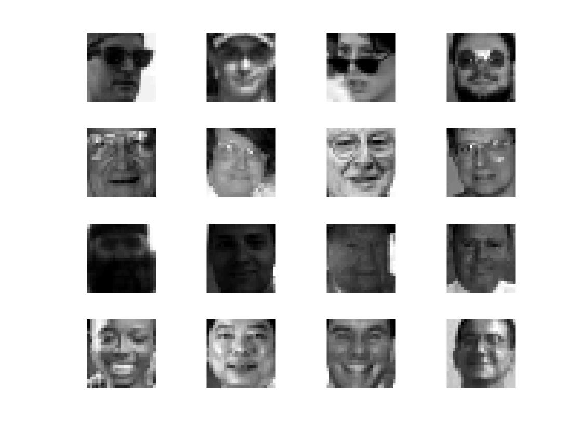**

Among the misclassified faces, there are several general trends. Shown here are 4 of those trends (one per row). From top to bottom: sunglasses or shaded eyes, glasses, low contrast, and shiny people. In the first two cases it seems the features which would recognize eye areas are obstructed. As people with glasses are a minority it will be hard to generalize to these people. The third category, low contrast, causes the Haar features to be very low, since there are few, low, edges/contrasts. In the last category, the shine on these peoples’ faces cause additional areas of light not present in most images, such as heavy contrasting of the cheeks and forehead, which might throw the method off.

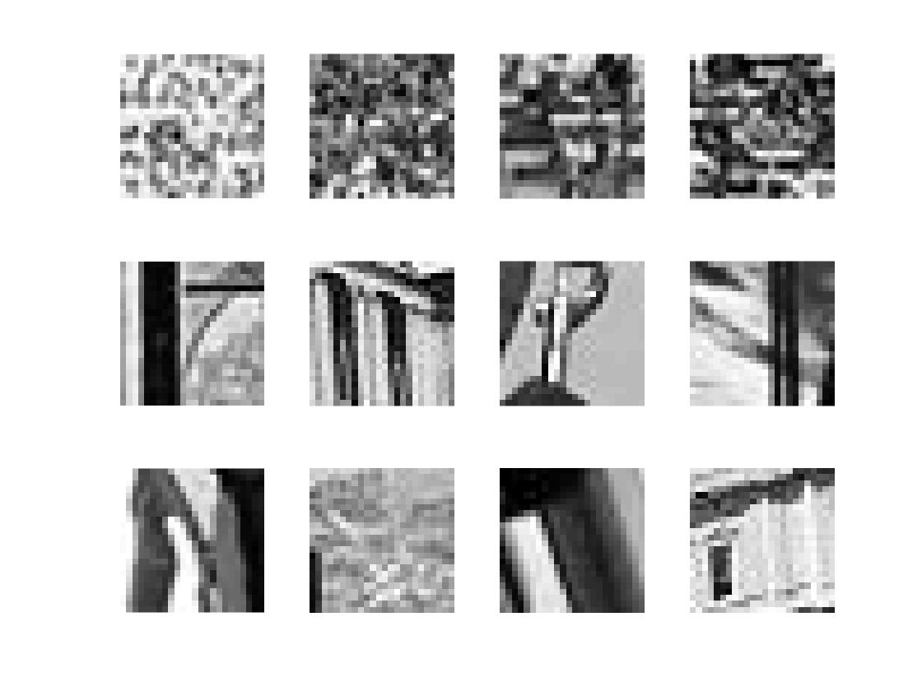For the misclassified non-faces, there is more variety in the images, but still some trends. We could identify 3, one per row: noise, vertical lines, and contrasts in the lower left corner. Heavy noise will generate a lot of contrasts, which is picked up by Haar features, and without context may be classified as faces because of random chace of the distribution of noise. The vertical lines are more difficult to explain. Perhaps vertical lines near the sides of the image are misconstrued as the edges of a face. Lastly, the “contrasts in the lower left corner” category might hail from overtraining. As can be seen above in question 4, one of the most used Haar-features is of the lower-left corner. Perhaps a lot of faces in the training set showed contrasts down there (the edge of the shin or something) while the non-face images which did were put in the test-set, making the classifier biased with regards to this feature.

1. **Defend your results. Are they reasonable?**

Yes, the results are reasonable. As mentioned, the mistakes in classification of faces seem logical, and although the mistakes in classifying other images are sometimes harder to initially understand they too seem to at least follow some patterns. Additionally, the test and training accuracy curves look reasonable, with the training accuracy continually approaching 1.0 while the test accuracy plateaued after further generalizability was impossible.

1. **Can we expect perfect results? Motivate your answer.**No**.** Due to the existence of poor images, due to that perfect generalizability is in general not possible as there is always differences between test and training data unless the amount of data available is infinite, and due to the limitations of the representation; Haar-features rely on chance for getting the perfect Haar rectangle filters required, and these filters are only horizontal or vertical and rather crude.